10 March 2025

Dear Resident,

**New Parking Scheme: Visitor Parking & Blue Badge Users Parking at Stockwell Park and Robsart Village Estates**

We recently informed you about an overview of the changes to parking on the Stockwell Park and Robsart Village Estates, which came into effect on Monday 3 March.

We would like to present a more detailed overview on the specific changes relating to Visitor Parking on the estates.

Please read the following carefully to ensure you understand the changes.

For further information, you can visit our website, visit us at our office, call switchboard or email [Parking@sw9.org.uk](mailto:Parking@sw9.org.uk)

Yours faithfully,

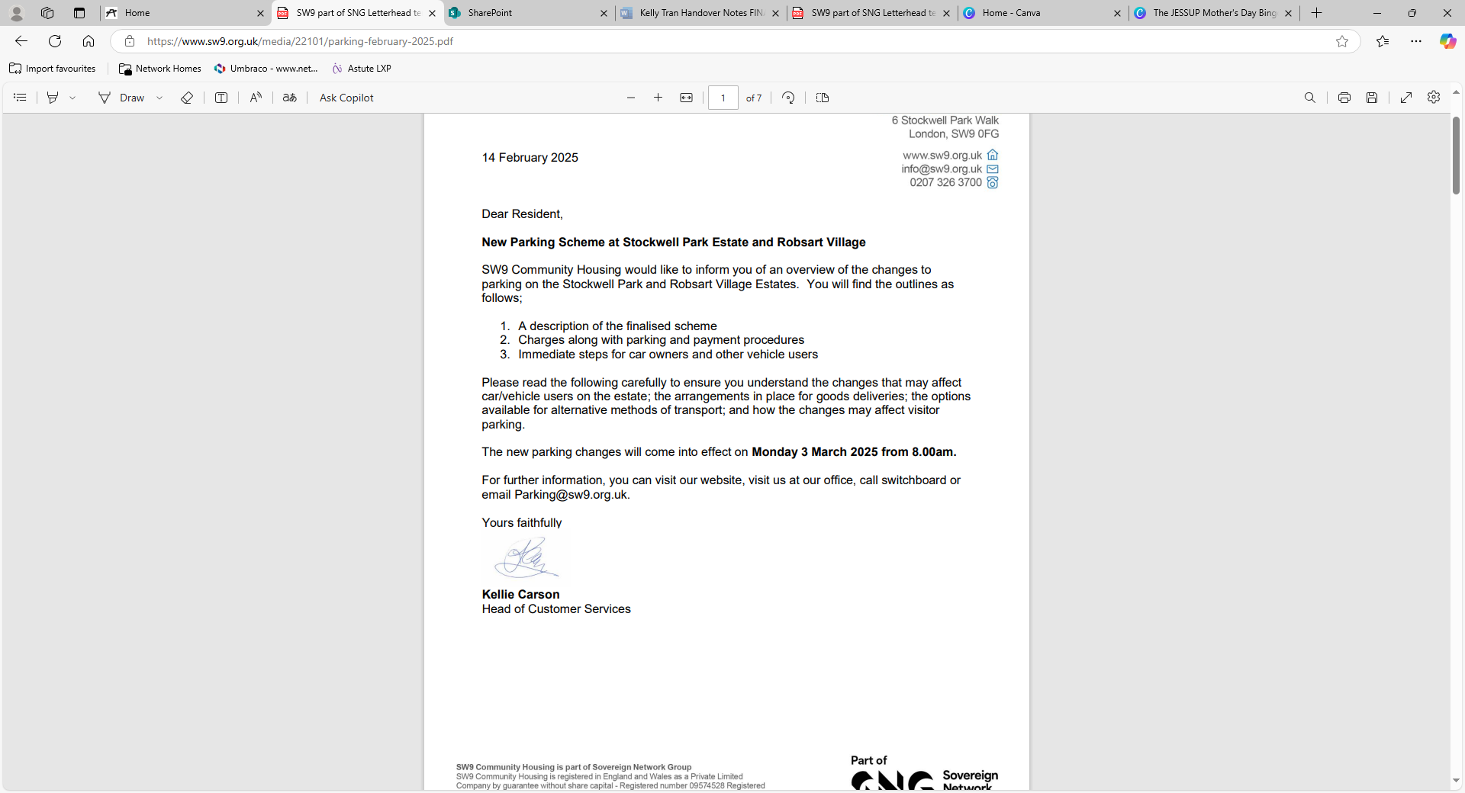

* Visitor-Only Parking Areas
* Benedict Road
* Lambert/Chute Courtyard (The Square)
* Dudley House Car Park

**Please note:** Lambert//Chute Courtyard is currently unavailable whilst our contractors are on-site carrying out works. We will provide further information when the area will be available.

**Visitor Parking**

All visitor parking bays will require electronic permits at all times, which can be accessed via the QR codes presented on signage and registered by mobile phone.

Visitor parking times are:

* 8.00am to 6.00pm, Monday to Friday,
* 8.00am to 2.00pm, Saturday
* At all other times an electronic permit is still required however, parking will be free.

Visitor parking is charged at:

* £ 5 for 6-hours visitor permit
* £10 for all-day visitor permit.

All visitors must ensure they have registered their parking period, otherwise they will be at risk of receiving a penalty notice.

**Blue Badge Users**

We have received a large number of Blue Badge users requiring disabled bays. We will be looking at our policies and will write to all residents regarding changes that may be implemented, in the coming weeks.

Residents with carers will have to provide parking for them, by paying for visitors parking, for the use of our visitor. At present, we cannot provide parking permits for carers.