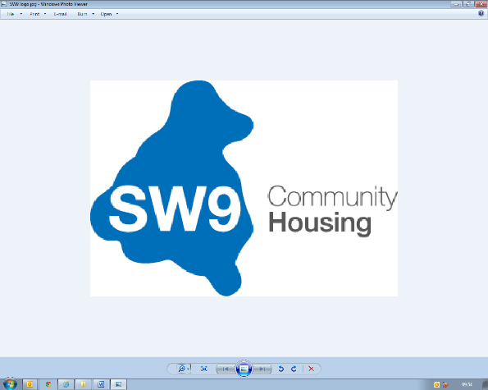 | Role Profile  2025
Job Title: | Legal Disrepair, Damp and Mould Surveyor
Reports into: | Technical Services Manager
Responsible for: | n/a
Department/ Location: | Operations/Stockwell
Disclosure Level: | Enhanced
Candidate Overview | The ideal candidate will be organised, a professional with a passion for ensuring high housing standards and an eye for detail, having technical expertise, legal awareness, and strong communication skills.
Role Purpose: | To provide specialist surveying expertise to address legal disrepair claims and manage damp and mould cases within SW9’s housing stock. Be able to diagnose damp and mould issues and provide expert reports for legal cases and remedial actions. Ensure the timely resolution of issues, compliance with legislation, and the delivery of high-quality housing services to tenants.  To be able to navigate both the physical aspects of property assessment and the procedural requirements of legal disputes, ensuring their work supports fair outcomes for all parties.
Key Responsibilities:
Legal and Disrepair Claims:

- Investigate and assess properties subject to legal disrepair claims under the Landlord and Tenant Act 1985 and the Homes (Fitness for Human Habitation) Act 2018.
- Awareness of typical obligations of landlords and tenants in maintaining property conditions.
- Prepare detailed reports, schedules of work, and photographic evidence for use in legal proceedings.
- Act as the organisation's expert witness in court cases or tribunals where required.
- Liaise with legal teams, insurers, and tenants to resolve disputes efficiently.
- Manage and monitor progress of disrepair cases to ensure compliance with court orders and settlement agreements.

Damp and Mould Management:

- Conduct detailed/thorough inspections to diagnose causes of damp and mould, including condensation, rising damp, or water ingress and other disrepair issues
- Recommend and implement remedial actions, including repairs, tenant education, and environmental controls.
- Diagnose, develop and deliver strategies to prevent damp and mould issues across the housing portfolio.
- Work closely with contractors to ensure quality and timely completion of remedial works.
- Assess the severity of disrepair and its impact on the property's habitability.

Customer Focus:

- Engage with tenants empathetically and professionally to address their concerns.
- Provide clear communication regarding planned works and expected outcomes.
- Promote tenant satisfaction through effective resolution of complaints and maintenance of safe, habitable homes.

Compliance and Record Keeping:

- Ensure compliance with relevant legislation, regulations, and organisational policies.
- Maintain accurate records of inspections, findings, and actions using the organisation’s housing management systems.
- Identify trends in legal disrepair and damp/mould cases to inform strategic decision-making.
- Advise on effective remediation and prevention measures.

Collaboration:

- Work with colleagues across departments, including Repairs, Asset Management, and Housing Services, to deliver coordinated responses.
- Support training initiatives for staff and contractors on damp, mould, and legal disrepair
issues.

Passionate about delivering 5* customer service
Standard Responsibilities
Adopt and comply with SW9 values, policies and procedures, and regulatory frameworks including:
- Code of Conduct
- Health and Safety
- Data Protection, privacy, and use of IT resources
- Regulatory standards and probity
- Risks and internal controls framework
- Human Resources policies and procedures
- Equality, diversity and Inclusion
The tasks and responsibilities outlined above are not exhaustive, the post holder may undertake other duties as is required.
Contacts - External/Internal
- Residents and resident representatives
- Contractors and consultants
- Executive Director, Senior Leadership Team, Operational Managers, and staff within SW9 CH
- SNG Property Services Team

Person Specification
Education | - HNC/HND or equivalent in Building Surveying, Construction, or a related field.
Desirable Knowledge | - Experience working within the social housing sector.  - Understanding of tenant engagement and customer service principles.  - Familiarity with energy efficiency measures to reduce condensation-related issues.  - Familiarity with housing regulations and legal standards for property conditions.
Experience | - Proven experience in diagnosing and resolving legal disrepair claims and damp/mould issues in residential properties.  - Comprehensive knowledge of housing legislation, including the Landlord and Tenant Act 1985, the Defective Premises Act 1972, and the Homes (Fitness for Human Habitation) Act 2018.
Skills  & Abilities | - Empathy and Sensitivity: Understanding the impact of poor housing conditions on tenants’ health and well-being.  - Strong diagnostic skills in identifying building defects and their causes.  - Excellent written and verbal communication skills, including report writing.  - Ability to manage competing priorities and meet deadlines in a pressured environment.  - Strong IT skills, including proficiency in housing management systems and MS Office Suite.  - Knowledge of Health and Safety legislation, including risk assessments and CDM regulations.  - Empathetic and customer-focused approach.  - Analytical thinker with strong problem-solving abilities.  - Ability to work collaboratively with internal teams and external stakeholders.  - Proactive in identifying and addressing risks
Systems | - Northgate -NEC  - Use of MS office  - Plentific  - CRM  - P2P  - SharePoint  - Competence in using IT tools, including Microsoft Office Suite
Competencies | - A flexible approach to working hours, with availability for evening and weekend events as needed.  - Commitment to fostering an inclusive, supportive community environment.  - Able to manage and prioritise demanding workload  - Meet deadline and KPIs  - Calm and professional  - Self-motivated and personal with a ‘can do’ approach  - Seeks opportunities for improvements  - Actively demonstrates interest in all aspects of the business
The tasks and responsibilities outlined above are not exhaustive, the post holder may undertake other duties as is required.
We want to make SW9 CH a great place to work and a great organisation that really delivers for its customers. Our HEART behaviours are designed to guide how we work, every day. Everyone within the organisation is expected to demonstrate the four HEART behaviours: -

Hungry
I am ambitious to succeed

- Optimistic: I am can-do and focussed on what can be done
- Creative: I find new ideas and solutions to challenges
- Bold: I get out my comfort zone and try new things
- Motivated: I welcome feedback and want to succeed

Embrace – I embrace everyone and support our colleagues and residents to feel confident in themselves, actively building an inclusive culture
- Supportive: I support everyone and value their individuality
- Ambassador: I strive to create an inclusive organisation
- Welcoming: I welcome all values and beliefs
- Inquisitive: I never stop learning and constantly seek a better understanding of the world

Accountable – I take personal ownership and responsibility to get things done I make things happen by empowering and delivering through the team and using resources effectively

- Resilient: I work hard to make things happen
- Disciplined: I am realistic and do what I say I will do
- Personal ownership: I take ownership of an issue until it is resolved
- Confident: I make decisions that are within my remit

Respectful – I treat everyone with respect and understanding I arrive on time and take full part in meetings

- Prepared: I arrive on time and take full part in meetings
- Communicator: I listen to others and work hard to communicate well
- Responsive: I always answer a ringing phone and respond quickly
- Self-aware: I put myself in others’ shoes and understand how my actions impact on others

Together – I am proud to be one team

- Positive: I talk positively about SW9 CH as one team
- Proactive: I put myself forward and build great relationships
- Supportive: I support and recognise the contribution of others
- Role model: I genuinely believe I make the difference

